**When we control input fields without states then it is called ‘uncontrolled component’.**

**We can control it with ‘useRef’ ↓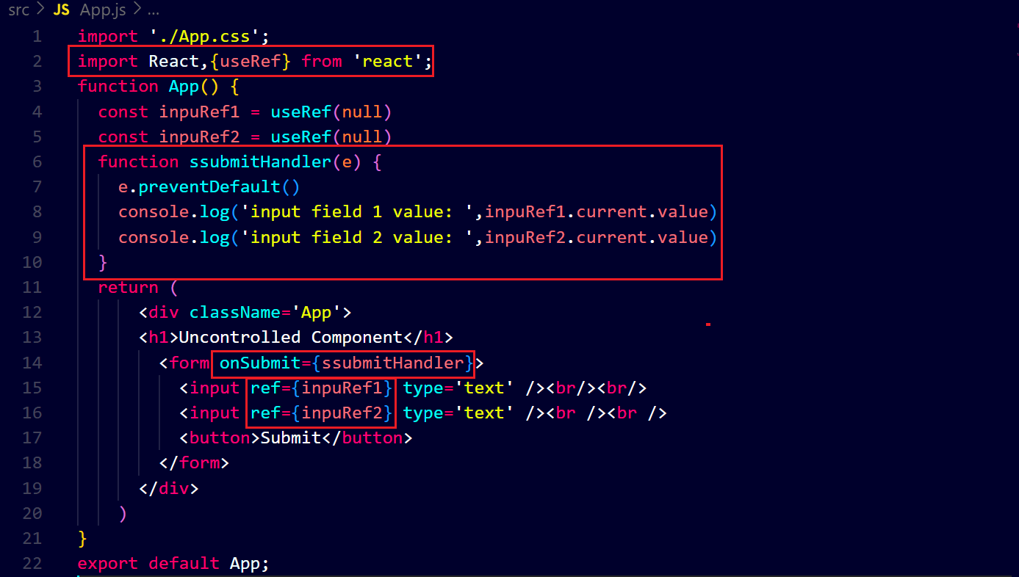output after clicking on the submit button ↓**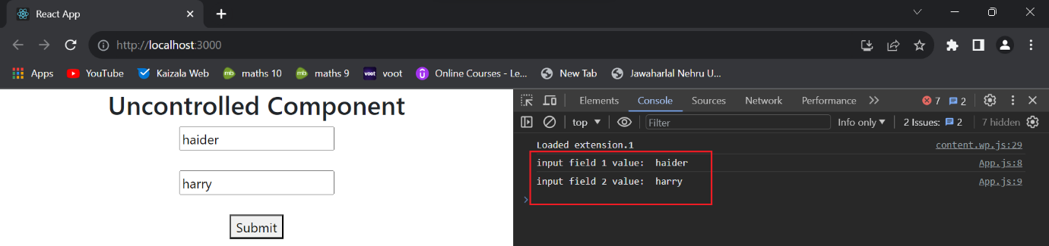

**We an control it using JS ↓**

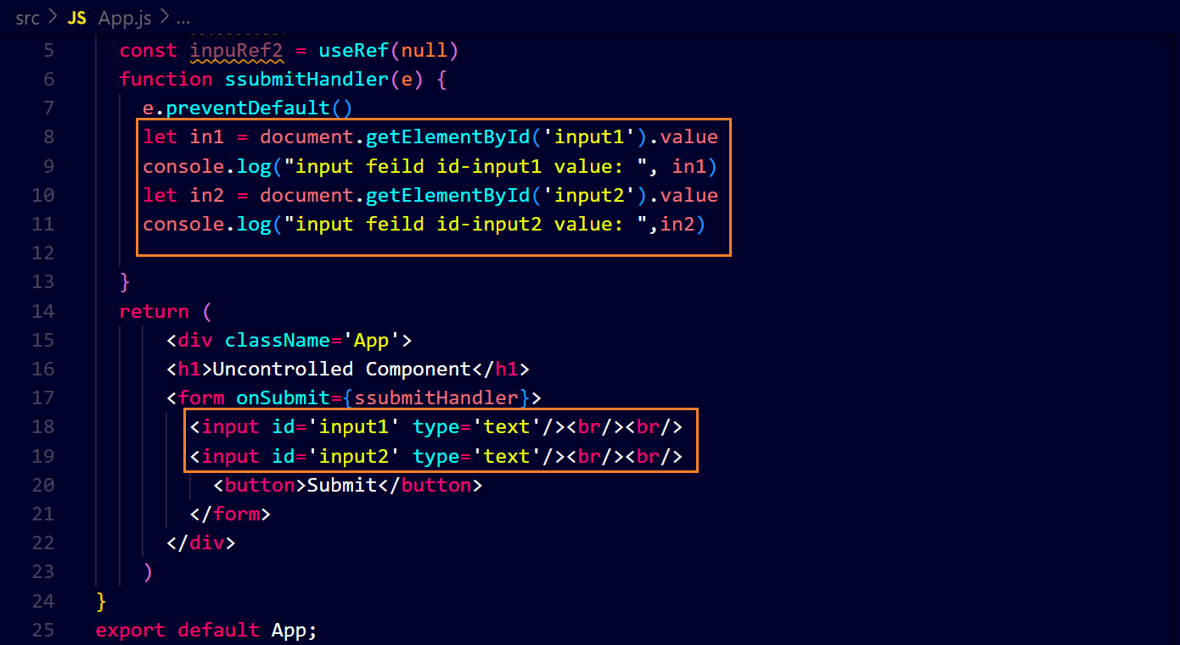 **output after clicking on the submit button ↓**